**Introduction to Block-Chain key-Concepts to Understand::**  
  
a. What is Web3 have any credit on how they are using it(security)=> no control of your own data.

* Get to know Torrent Networks works
* In Web2 Your data on free Google services or YouTube are being traded while you thought its free and you don’t have any credit on how they are using it(security)=> no control of your own data.
* The applications that are running on distributed networks(DAPs)

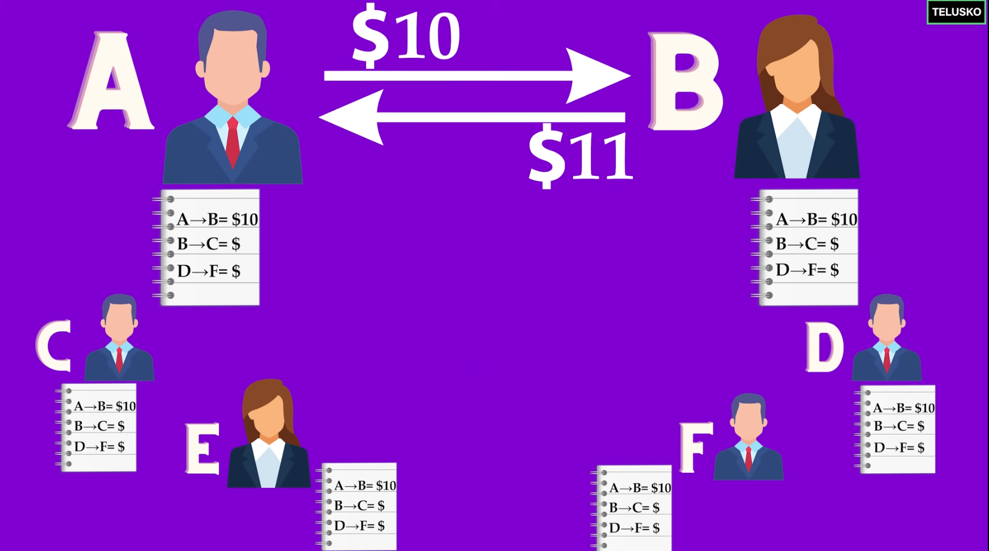

* On Web3 you own your data.

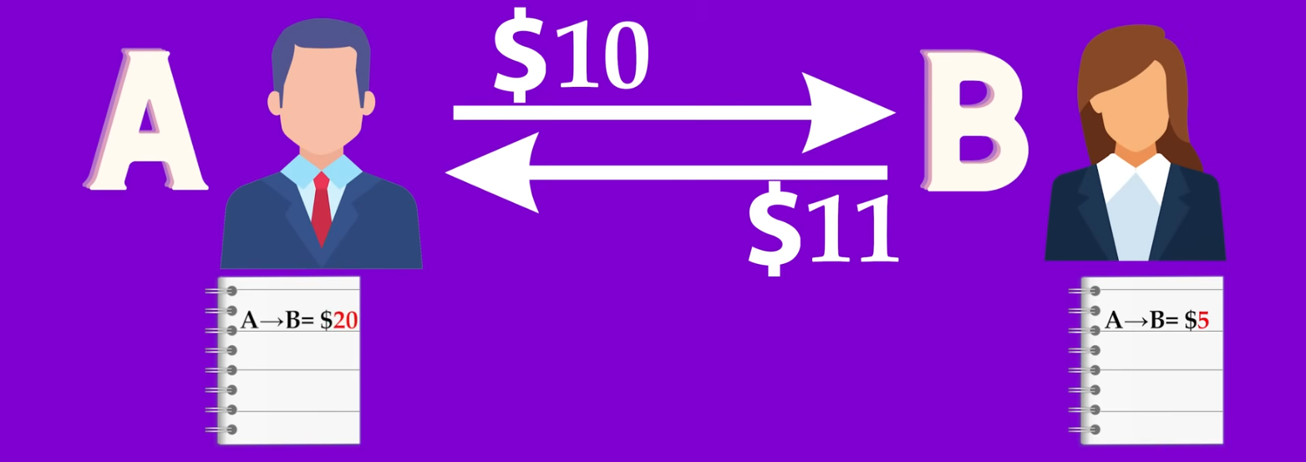

b. What is Block-Chain?

* Moving from Centralized->Decentralized (who will control our own data?).
* Data on Web3 is immutable (everyone can see if someone want to make forgery).
* If someone try to modify data as a **miner** on web3 we can notice him/her a kick him out of our network.

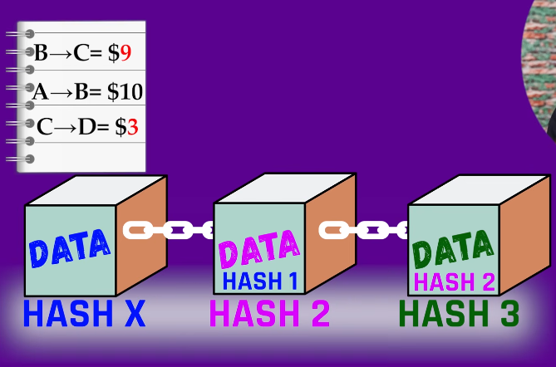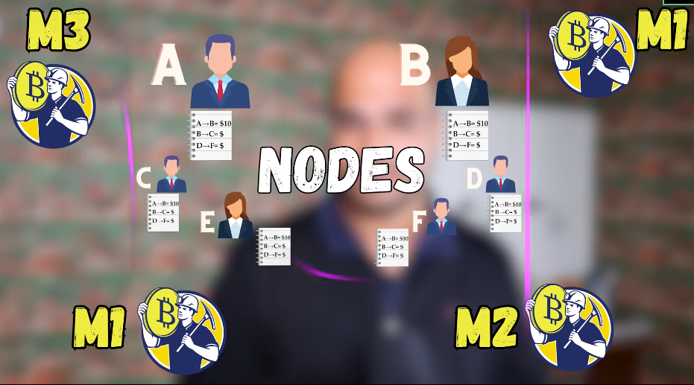

c. Why Block-Chain (who, why, and what are prerequisites)

* Block chain provide **Trust**
* Prerequisites are cryptography and distributed computing.

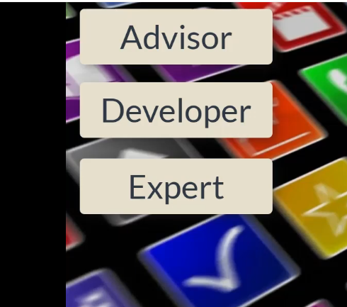

d. Cryptography.

* Confidentiality (none can see that data)
* Integrity (none can modify our data)
* Non repudiation. (proof of message transferred).
* Authentication. (None must send message to someone’s else behalf).
* Crypt(Hidden)-Graphy(Written)=>Encryption

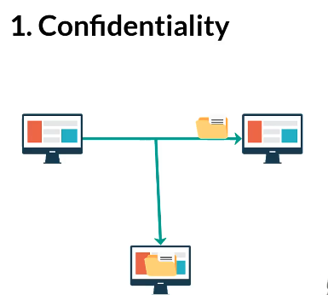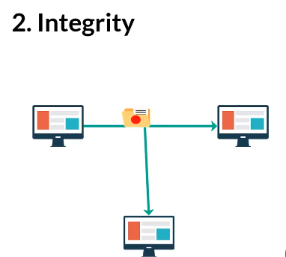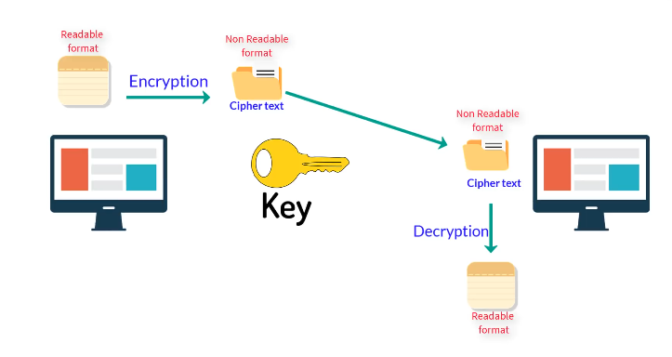

e. Types of Cryptography

* **Symmetric-Key Cryptography** (same key=> tedious).

As number of user increase we need to increase number of keys..

* **Asymmetric-Key Cryptography** (public and Private key)

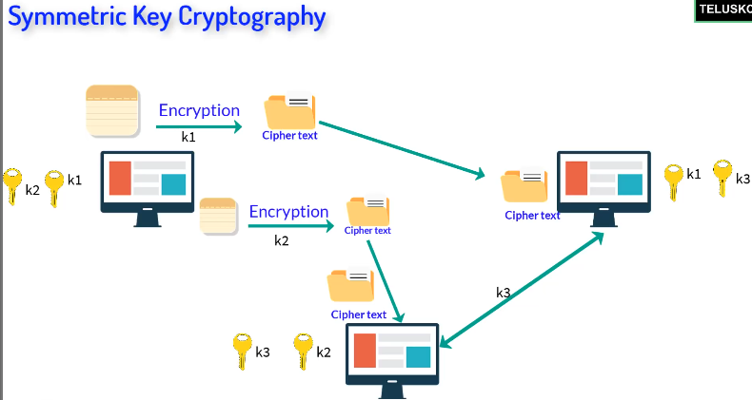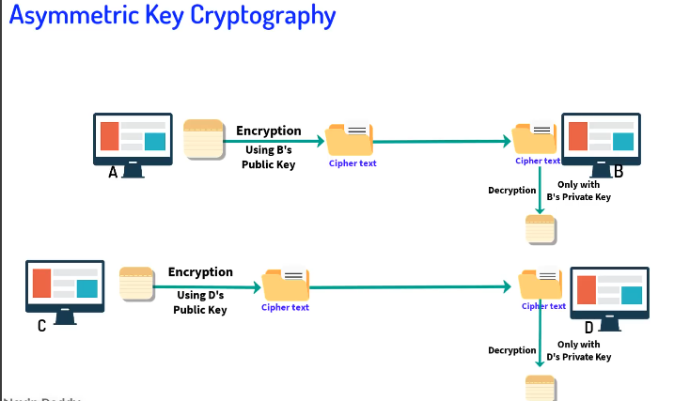

f. Digital Signature. (solve problems in network)

* We need to know who is exactly sending the data (like written letter signed to confirm its you).

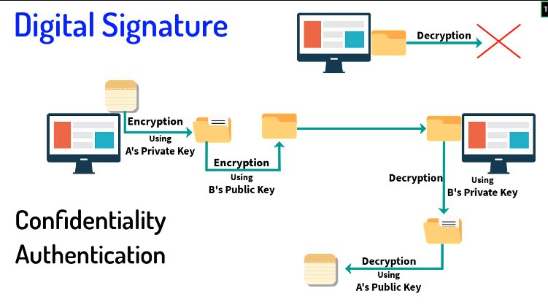

g. Nodes in Block Chain.

* Full Node needs at least good processing CPU’s and GPU’s in 188GB and it verify and store block-chains.
* Partial Node can be like PC/cellphones to download the app and use to trade (on purpose).

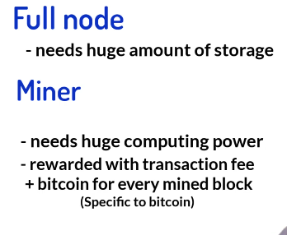

h. Hashing in Block-Chain

* You cannot get data back in hashing like encryption-where it uses decryption.
* We can use algorithms like MD (Message Digest), SecureHashAlgorithm(SHA).

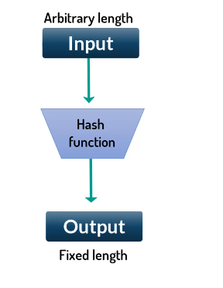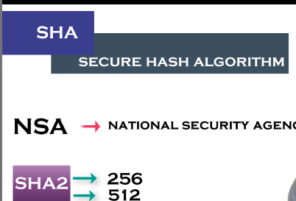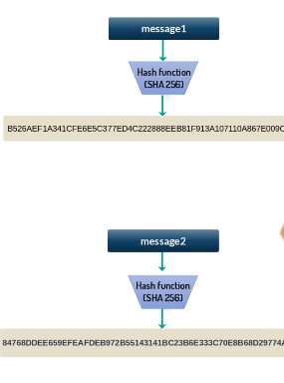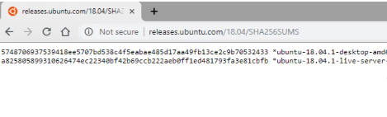

1. MerkleTree_MerkleRoot.

* We need to have only one hash for each transaction.

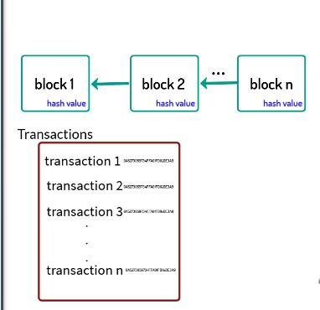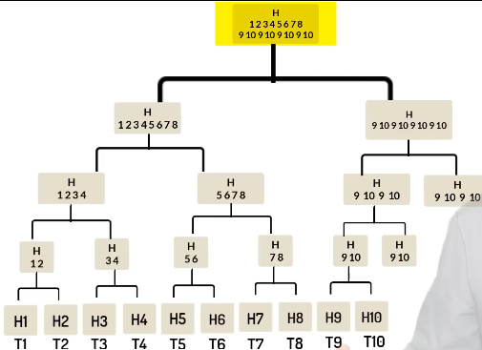

j. Blok_chain_Technology_Architecture

* Consensus Algorithm give nodes to verify your proof of work
* To add or modify data to block chain you need 50% majority.

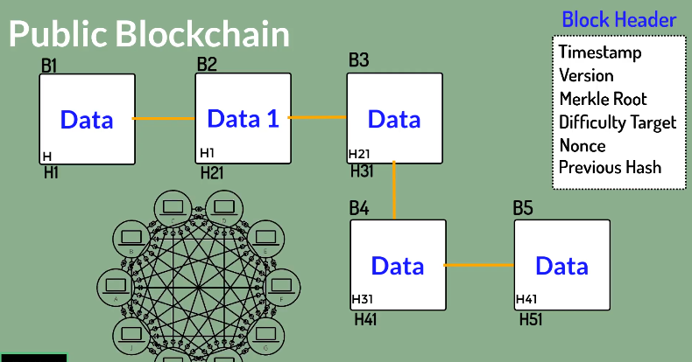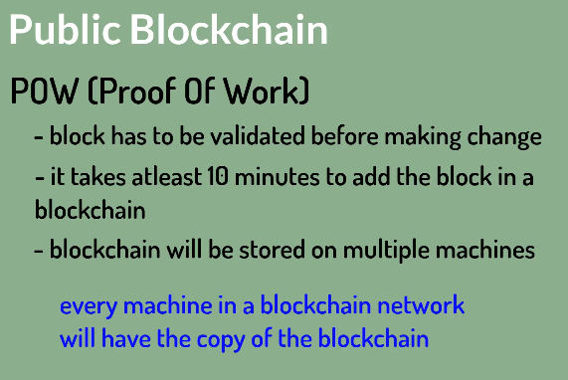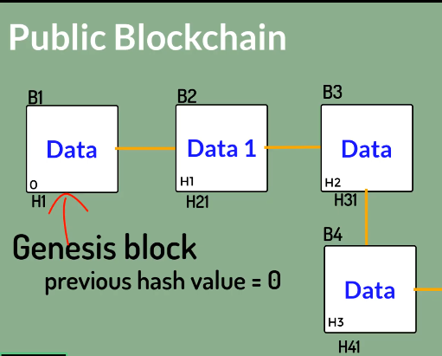

k. Types of Block chain

* Public Block-Chain is open and everyone can be part of it (slow we need POW).
* Private Block-Chain is specifically for a single company (fast-> no need of POW).
* Federated Block-Chain is group of people /companies.

l. Consensus in Block-Chain

* We give miners (not malicious) puzzle to solve and use their computing power, one who wins, add the block-to chain and got rewards. And using consensus we can agree on some state on block-chain network.
* Algorithms like POW(work),
* POS(stake) where too much investors(coins**$**) got trust.
* POET (Elapsed time), POD (deposit), POC(capacity)

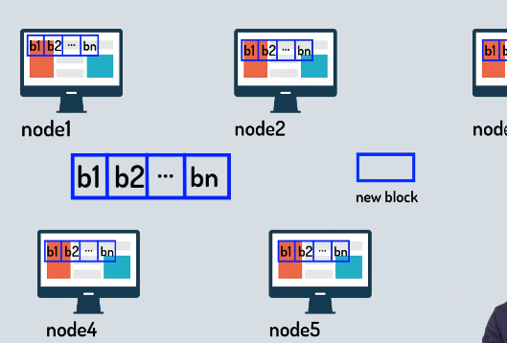

m. Proof of Work. (Bitcoin)

* There’s is a competition of math-calks who win add block in chain and get rewards.
* Issues (spending too much idle power, and may be 51% of nodes are malitious)

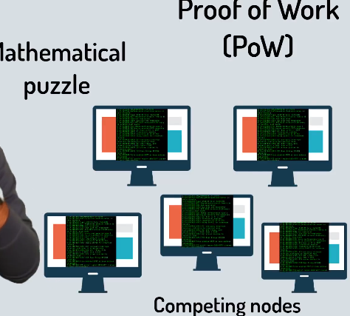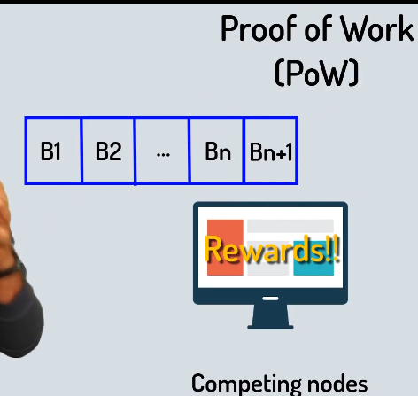

n. What is Etherium.

* BitCoin is peer-to-peer electronic cash system.(CryptoCurrency)
* To write apps/softwares we have Etherium(DApps)
* To be able to use crypto currency in ethereum we need **Ether.**
* **Def:** it’s simply a platform where you can build your decentralized applications/softwares, it also has its own cryptocurrency **Ether.**

m. Smart Contracts(**Trust/secure)**.

* **Prepaid** transactions trust issues.
* **Are** lines of codes built and run on ethereum networks to make contracts.

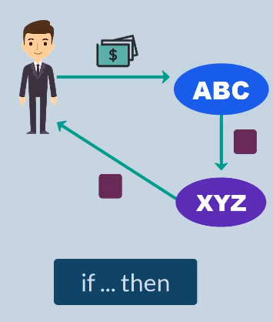

o. Drawbacks of Block-Chain. (mostly public)

* Complexity of many terms & algorithms and even technology.
* Slow Speed [**VISA** handle 1000s transactions/sec] ! [**Bitcoin** handles 7-10 trans/sec]./day
* Wastage of resources to handle their algorithms
* Security/Privacy (the data is there in block chain; everyone can see it).
* 51% attack. ( it can be hacked).

But on private we can handle some of these issues.

p. What is HyperLedger.

* It is not block chain, company or cryptocurrency as well.
* It is a project. Hosted by Linux foundations and accepted from other big-techs(Amazon,Google,IOT,Industry,…).
* Umbrella or Greenhouse for block chain open source products. (B2B) in which you can build block chains.

q. What is NFTS?

NFTs (Non-Fungible Tokens) are like **digital ownership certificates** that prove you own a unique item on the blockchain.

**Real-Life Example:**

Imagine you buy a **rare, one-of-a-kind trading card** (like a special edition Pokémon or sports card). Even if other people have similar cards, yours has a unique **serial number** proving it’s the only one of its kind.

Now, in the digital world, NFTs work the same way! Let’s say an artist creates a **digital painting** and turns it into an NFT. When you buy that NFT:  
✅ You **own** the original digital artwork (even if others copy or download it).  
✅ Your ownership is **recorded on the blockchain** (a secure public ledger).  
✅ You can **sell or trade** it, and the blockchain will track ownership changes.

So, NFTs make **digital things** (art, music, videos, virtual land, etc.) **unique and ownable**, just like physical collectibles. 🚀

Thanks!!!!!!!!!!!!!